REV. | Description | Date
00 | 102A-239264  增加ADP-200JB KA,ADP-200JB KB與ADP-200JB HA,HB,HA88,HD,HC合併發行 | 10/02’23
01 | 102A-23C159  Update Mechanical/10.Acoustic Noise | 12/18’23
02 | 102A-243256  更新item 6.5 Plug P/N  ADP-200JB KA/KB PLUG CHANGE TO ACES 56923-02022-101 | 03/26’24
03 | 102A-243304  FOR ADP-200JB KA/KB  ADD 2.3.5 DC Plug OTP | 03/29’24
04 | 102A-245210  ADD model ADP-200JB KA-2,ADP-200JB KA-3  102A-245211  ADP-200JB KA1W | 05/22’24
MODEL LIST
ADP-200JB HA | ADP-200JB HB | ADP-200JB HA88 | ADP-200JB HD | ADP-200JB HC
ADP-200JB KA | ADP-200JB KB | ADP-200JB KA-2 | ADP-200JB KA-3 | ADP-200JB KA1W
- Introduction:
This specification define the input, output, performance characteristics, environment, noise and safety requirements for the power supply.
2. Electrical Requirements:
- Input Requirements:
    - Input Voltage
-Normal voltage: 100~240Vrms
-Voltage Range: 90~264Vrms
    - Input Frequency
-Normal Frequency: 50~60Hz
-Frequency Range: 47~63Hz
    - Input Current
-Under 2.5 Arms at 100Vac & Max. load
    - Configuration
-3 Conductors (Line, Neutral, Ground,)
    - Input Fuse
-An adequate internal fuse on the AC input line shall be provided.
    - Inrush Current
-The inrush current of the power supply shall be less than the rating of its critical components (include bridge diode, surge limiting device) for all condition of line voltage of 2.1.1
-The I^2t shall less than 22% of the fuse, surge limiting device and bridge diode rating.
    - Efficiency
-The power supply shall meet DOE VI & COC V5 Tier 2 request.
-Four point average efficiency at 25%,50%.75% and100% loading shall be more than 89% after burn in 30 minutes measure at 115V/60Hz and 230Vac/50Hz
-The efficiency at 10% loading shall be more than 79% measure at 115V/60Hzand 230Vac/50Hz

    - Power Factor
-0.9 min @ full load at input AC power 230Vac.
-With active PFC function to meet EN61000-3-2 harmonic current requirement.

    - Primary Aluminum Capacitor
- 450Vdc (min.)
- Output Requirements:
    - Electrical
No. | Item | Condition | Specification
1 | Output Voltage | Rating | 20V
1 | Output Voltage | Output Voltage Range | 19~21V
1 | Output Voltage | Ripple & Noise | 350mV
2 | Output Load Current | Operation Max. | 10A
2 | Output Load Current | Operation Min. | 0A
3 | 2) Transient Load Current | Current | 0.05~10A
3 | 2) Transient Load Current | Transient Frequency | 100Hz ~ 100KHz
3 | 2) Transient Load Current | Slew rate | 2.5A/us
2) The output voltage regulation shall less than( +/-5% )of the rated output voltage in transient mode.
    - Output Voltage Requirement
-The total output voltage regulation shall be meet the spec., including the effects of AC line voltage variation, load current, ripple and noise.
-The effect of transient load changes is included in this limit.
    - Overshoot
-The output overshoot at turn on shall not exceed 21 voltage value with or without the load connected.
    - Hold Up Time
-The power supply shall maintain voltage regulation within the specified limits in paragraph 2.2.1 for at least 16ms after lost of input voltage measure at 100Vac and at maximum output load.
    - Output Rise Time
-At turn on the rise time of output voltage shall be less than 40ms.
*Measured from the 10% point to the 90% point of the normal.
    - Turn On Delay Time
-No Load Power Consumption supply shall reach voltage regulation within the specified limits in table 2.2.1 for 3sec max. after AC input the power supply.
-The input voltage measure at 100/240Vac and at maximum output load.
    - No Load Power Consumption
-Maximum non-load power consumption is less than 0.15W at 115Vac/60Hz and230Vac/50Hz
    - Power saving requirement
-Vin=115Vac/60Hz and 230Vac/50Hz
Output Power (W) | Pin Power (W) | Eff%
18 | < 23.5
5~6.5 |  | > 80%
11 | < 14
3 | < 5
1.65 | < 3
1.5 | < 2.2
1 | < 1.6
0.25 | <0.45
    - Surge load:
The adapter shall support a surge load with 120% of maximum load for 1min ,maximum load for 9min and Output Voltage more than 18.5V at input voltage is 100-240Vac
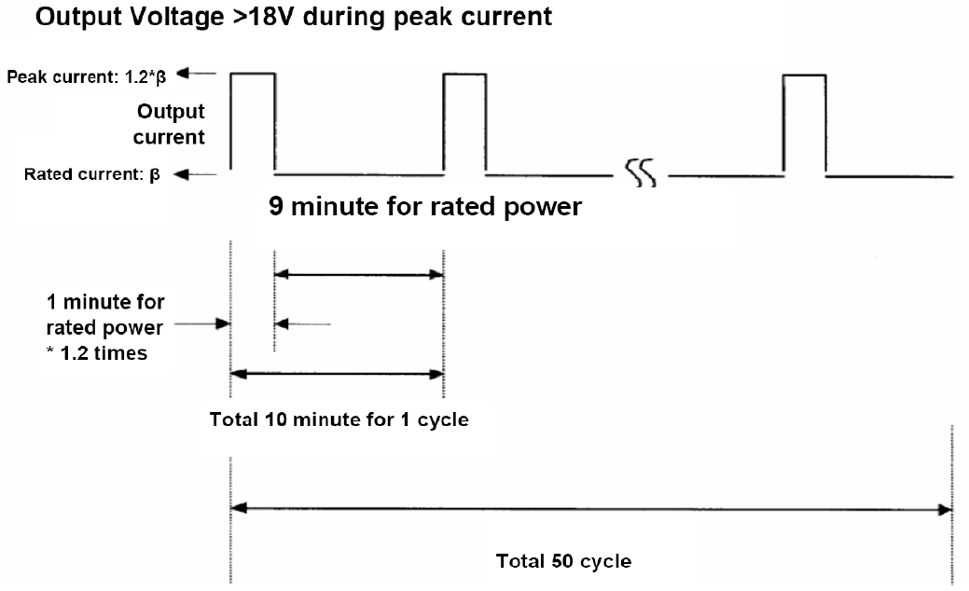

    - Peak load:
The adapter shall support below loading condition without any damage, safety issues and protection happen (OTP is allow). The output voltage shall more than 18.3V at input voltage is 100-240V/50Hz .
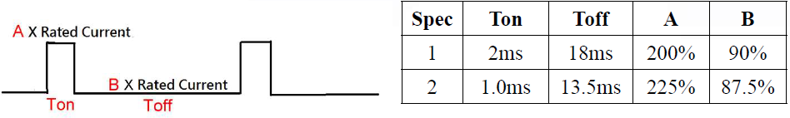
    - Hot Plugging:
Plugging a live AC adapter into the system with 2000 uF capacitance shall not trigger
any protections or cause the adapter to shut down
2.2.12 Voltage Dips
Follow the test item “ 30% reduction , 25 periods ” in IEC 61000-4-11 Standard.
Criteria : A
(a) AC Input = 100Vac/50Hz
(b) Load : Full Load
- Power Output Protection:
    - Over Current Protection (OCP)
-The maximum constant current shall be less than 12~16A at 90Vac and 264Vac.
-The adapter Shall be Latch off and no component damage.
-Debounce time 400ms
    - Over Voltage Protection (OVP)
-The output shall be protected to latch off at over-voltage condition,maximum value can’t be over 27V.
    - Short Circuit Protection (SCP)
-The power supply short output shall be Latch off and no component damage.
    - Over Temperature Protection (OTP)
The adapter shall be Latch off and no component damaged, no fire and no melting
of the enclosure.
    - DC Plug OTP(FOR ADP-230JB KA/KB)
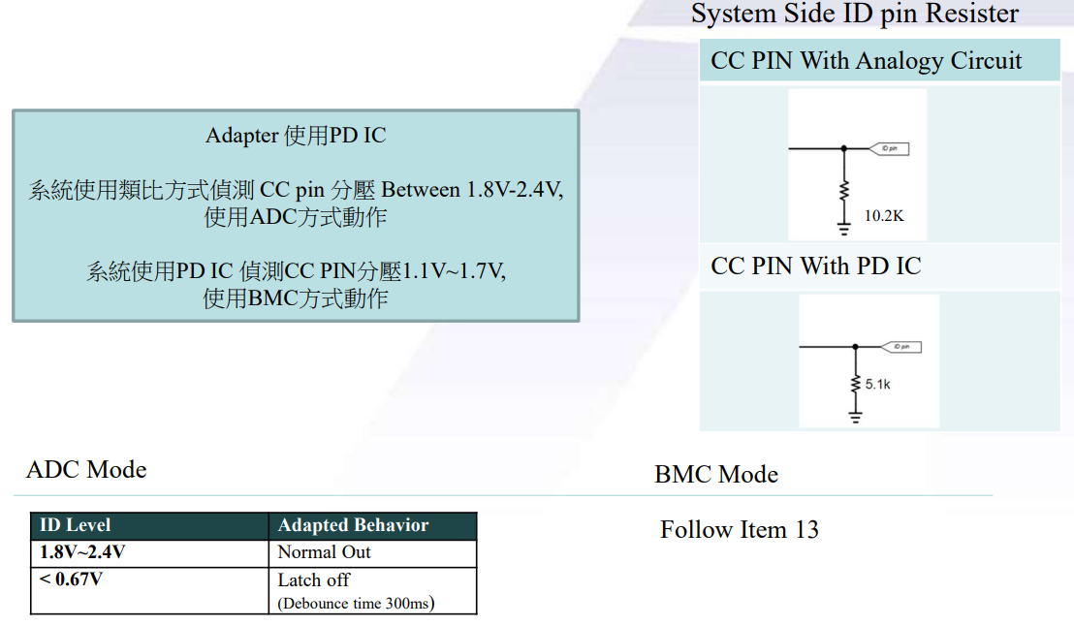

3. Reliability:
- MTBF:
-The power supply shall be designed and produced to have a MTBF of 150,000 operation hours at 90% confidence – level while operating under the following condition
-AC input voltage: 100 and 240Vrms
-Ambient Temp. : 25℃

- Life/Power On Hours
The lifetime is least 26280 hours in Full load at 25℃ at 100Vac/60Hz and 240Vac/50Hz on bakelite.
- Burn-in Test Condition
- More than 4 hours at 35°C, normal input voltage.
- AC on/off must be tested.
- Surge Voltage (For DT Type Only)
1. 264Vac to 400Vac for 1 min
2. 264Vac to 430Vac for 2sec
3. Bulk Cap : 450Vdc
4. Safety & EMC:
- Safety Certificate
- The power supply unit shall be tested with the following safety standard (IEC62368-1 3nd).
- Certificate : Follow safety control table
-Trade mark: ASUS
- Insulation Resistance
- Insulation resistance shall be > 30M ohm at 500Vdc between primary Live, Neutral and secondary.
- Hi-Pot Test
-Primary to Secondary : 3.0KVac or 4242Vdcfor 1minute
-Primary to FG :1.5KVac for 1minute
- Leakage Current
-The power supply leakage current shall be less than 100 uA.@240Vac/50Hz
-Test with AC cable 80cm
- Surge & Impulse Test
-Lighting Surge : ±1.5KV (L-N) ; ± 2.5KV (L-FG; N-FG)
-Impulse Noise Test: 1KV

- EMI standard
-The power supply shall comply with a following RFI/EMI standards when tested in asystem configuration.
-F.C.C part15
-EN55032
-The limits shall be met with a margin more than 6dB at all applicable.
- Electrostatic Discharge (ESD)
This Adapter is capable to withstand ESD test voltage at any point around the enclosure asbelow.
±15KV air discharge Performance Criterion A.
± 8KV contact discharge Performance Criterion A.
5. Environment Requirements:
- Temperature
-Operation: 0~35°C; Storage: -30~80°C
- Humidity (no condensing)
-Operation: 5~90%; Storage: 5~90%
- Surface Temperature rise
- Output 200W and ambient 25℃; input voltage 100Vac/240Vac 50Hz
Top case temperature rise<45℃,Bottom case temperature rise<50℃
- Acoustic test:
Input Condition
90V/47Hz & 254V/63Hz
Load Condition:
Dynamic load: 0.05~10A at 100Hz and 100KHz
static load(from 0A to full load,0.1A pre step)

NB ADAPTER SPEC :
Static Load
Desktop Type : Microphone at a distance of 5cm from the surface and noise level is less than 20dB
Dynamic Load
Desktop Type : Microphone at a distance of 5cm from the surface and noise level is less than 25dB

6. Mechanical
6.1 Outline Dimension: 152.0 * 72.5 * 23.0 mm, color: Black
6.2 AC Inlet Type: Socket C6 type
6.3 DC Cable length: 1800±50 mm
6.4 DC Cable Type:
Cable Type | Model Name
UL1571 16AWG | ADP-200JB HA/HB
UL11352 16AWG | ADP-200JB HC/HD
UL 20276 16 AWG | ADP-200JB KA/KB/KA1W/KA-2/KA-3

6.5 DC Connector Dimension:
 | Item
Model Name | Plug Shape | Outside Dimension (-) | Inside  Dimension (+) | ID Pin | Length
ADP-200JB HA/HB | Right Angel (L-shape) | 6.0 | 3.5 | 0.6 | 11.5
ADP-200JB HD | Right Angel (L-shape) | 4.5 | 2.9 | 0.6 | 10.0
ADP-200JB HC | ASUS方型 | 方型 7.5*3.9 |  |  | 10.1
ADP-200JB KA | ASUS方型 | 方型 7.5*3.9  PLUG: ACES 56923-02022-101  DC JACK : ACES 56921-01902-Z01 (REF.) |  |  | 10.1
ADP-200JB KB | ASUS方型 |  |  |  | 10.1
ADP-200JB KA1W/KA-2/KA-3 | ASUS方型 |  |  |  | 10.1
6.7 ADP-200JB H SERIES Adapter Weight: 496g ±2.5%
6.8 ADP-200JB K SERIES Adapter Weight: 472g ±2.5%

Mechanical characteristics
 | Item | Conditions | Specification
1. | Cord flexibility test(Delta) | Hang the specified weight and swing it to one direction and return to the original position then swing to the opposite direction and return to the original position. This constitutes one cycle. The DC power supply shall be subjected to the specified cycles a specified speed.  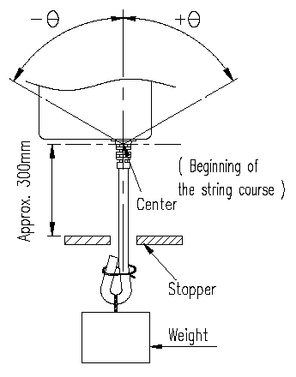  Delta SPEC.  - Weight: 200g  - Swing angle (θ): 0°~ 180°  - Cycles: 1000,3000,10000cycles  - Speed: 40 cycles/min.  - Compliance:  Plug SR, case SR, Core SR. | Disconnection rate of the wire shall be  1000 cycles –less 10%  3000 cycles – less 30%  10000 cycles – less 100% without damage to the insulations, etc..
1. | Cord flexibility test(ASUS) | Hang the specified weight and swing it to one direction and return to the original position then swing to the opposite direction and return to the original position. This constitutes one cycle. The DC power supply shall be subjected to the specified cycles a specified speed.  Customer SPEC.  - Weight: 200g  - Swing angle (θ): 0°~ 90°  - Cycles: 3000,10000cycles  - Speed: 40 cycles/min.  - Compliance:  Plug SR, case SR. | CRITERIA:  Disconnected rate of the wire shall be:  - Case SR  3000 cycles – less 10%  10000 cycles – less 100%  - Plug SR  3000 cycles – less 30%  10000 cycles – less 100%  - Without damage to the insulations. Etc.
2. | Cord tensile test | A static load shall be applied and sustained for a period. Excessive load shall not be applied in this test, unless special request.  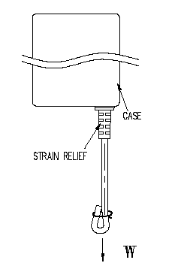  Load (w): 10 kgf  Durance: 60 sec | Contact part and bushing shall not be detached.

 | Item | Conditions | Specification
3. | AC plug in-out cycle test | AC plug in-out of AC inlet 6000 times, 30 times/min. without current flow.  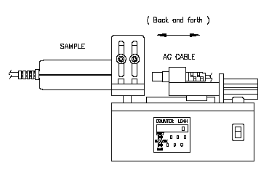 | 1. No found the AC inlet or pin damage.  2. ATS function Pass. Without distinct damage in appearance.  3. Refer to IEC 320 requirement.
4. | AC socket insert-withdraw force test | After AC plug in–out cycle test , AC cable insert-withdraw to AC inlet 10 times  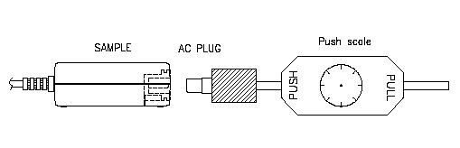 | 1. Insert force must be keep 10N ~ 50N.  2. Withdraw force must be lower 60N.  3. This test depends on IEC 320 requirement.
5. | Wiggle test | AC cable inserted fully into AC inlet to wiggle 6000 times, 30 times per minute, then adjust the fixture to fit the wiggle angle in up and down each side 5 degree, ac cable up and down without current flow. (example: L=40 mm , amplitude = +- 3.5 mm , force = 10 kg )  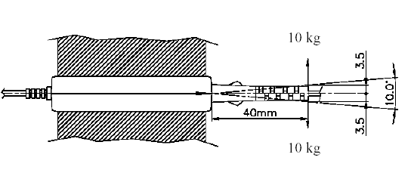 | 1. After this test, no found the AC inlet or pin damage.  2. Without distinct damage in appearance.  3. ATS function Pass.
6. | Vibration | Non-operating, Random vibration:  5~100 Hz 0.015 G2/Hz  100~137 Hz 6 dB/oct  137~350 Hz 0.008 G2/Hz  350~500 Hz -6 dB/oct  Acceleration: 2.09 Grms  Duration: 20 min.  Direction: X,Y,Z | 1. PSU must operate with specification after non-operation test.  2. PSU shall be no mechanical damage after test.
7. | Shock | Non-operating  1. Pulse: Half sine wave.  2. Peak acceleration: 50 G  3. Duration: 11 ms  4. Number of shock: 1 shock per each direction, 6 directions. | 1. PSU must operate with specification after non-operation test.  2. PSU shall be no mechanical damage after test.

 | Item | Conditions | Specification
8. | Drop test  (Delta) | 1. Operating  a. The drop height: H= 76 cm.  b. The drop orientation: 6 face for each.  c. Power on | - ATS function Pass.  - No PWB copper pad peeling and broken.  - No soldering crack.  - No component broken.
8. | Drop test  (Delta) | 2. Low height drop  Drop TIMES: 130 times for every surface (six side), 780 times in total.  Test surface material : The concrete  Drop height: 10cm
8. | Drop test  (Delta) | 3. Non-operating  a. Drop height: H= 110 cm.  b. The drop orientation: 6 face for each. | - Hi-pot test pass with specific condition.  - Test Finger can’t touch the Hazardous Voltage of the product.
8. | Drop test  (ASUS) | - Drop 8 times (6 faces) on each cycles from a height of 1.0M onto a concrete surface.  Increase the height in steps of 0.2M until the case is broken.(or 1.3M)  Must has 10cm margin during design stages. | CRITERIA:  - Electrical: The unit should meet all specification and no function error after test 1.1M testing  - Mechanical: There shall be no visual damage and safety concern after 1.3M testing.
8. | 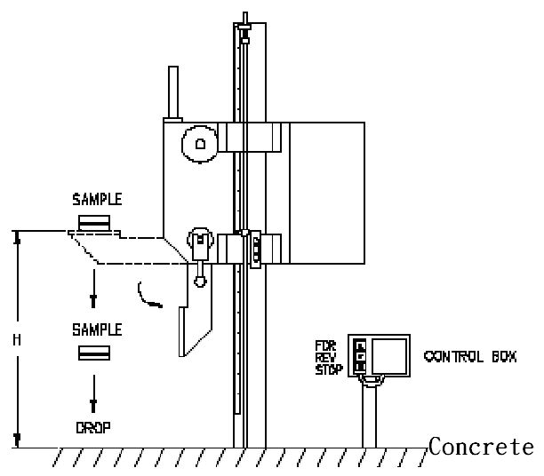  Equipment:

9. | Ball impact | 1. Steel ball: 0.54 kgf .  2. Drop height: 130 cm.  3. A horizontal surface of laminated wood of hardwood at least 13mm  thick, mounted on two layers of plywood each 19mm to 20mm thick,  all supported on a concrete floor.  4. Impact location: Classify according to DUT’s dimension. LxWxH  L+W <150 B,D,F,H,I,K  150<L+W <200 A,C,D,E,G,H,I,J,K,L  200<L+W A,B,C,D,E,F,G,H,I,J,K,L  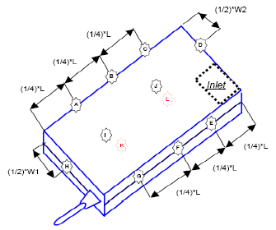  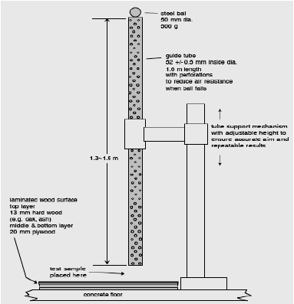  5. Equipment: | 1. Hi-pot test pass with specific condition.  2. Test Finger can’t touch the Hazardous Voltage of the product.
10. | Acoustic Noise | Frequency: 100 ~ 20kHz  Measurement distance: 5 cm above DUT surface | The Adapter shall produce no human perceivable audible noise (less then 25dB)  No load：< 22dB  0~Full Load：  Frequency≦15kHz, 25dB Max.  Frequency＞15kHz, 30 dB Max.
11. | Adhesion of specification labels | Firmly apply pressure sensitive adhesive tape on the middle of the specification label to the lengthwise direction.  Pull the tape off quickly at a 90∘angle to the surface of the label once.  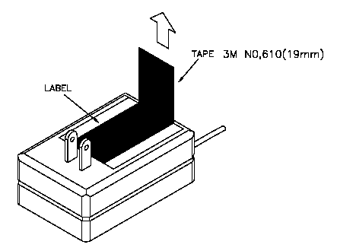 | There shall be no blistering or peeling of the specification label
12. | Label Temperature test | 1. The label is supposed to be pasted on PC, PC+ABS and ABS case evenly and properly for 24 hours.  2. The label will be burnt in 72 hours in oven which temperature is 85℃  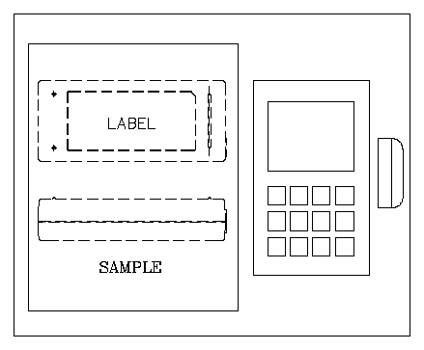 | The label can’t be any bulge and warp.
Product Application: Notebook
Product Ingress protection(IP) rating: Not requirement

